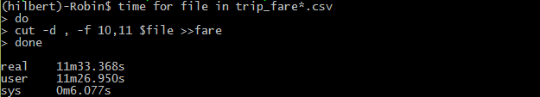

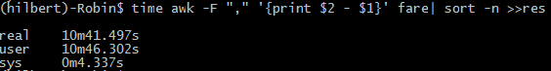

用R+shell 处理response 要560sec

Predictor 要 914sec

用data.table包处理 response要354sec rbindlist 50sec 做减法 1sec

Predictor 要385sec rbindlist 95ec

用lm求回归 361sec

Shell:

Intnercept: 1.452e+01

Pred:2.060e-05

Use parallel apply to readVar function and readPred

Resp : Time:63sec

Time:89sec